**SRM INSTITUTE OF SCIENCE & TECHNOLOGY**

**RAMAPURAM CAMPUS, CHENNAI-600 089.**



**DEPARTMENT OF COMPUTER SCIENCE AND ENGINEERING**

**B.TECH CSE – H SECTION - IIYEAR / IV SEMESTER**

**18CSC206J - SOFTWARE ENGINEERING AND PROJECT MANAGEMENT**

**TITLE: ONLINE BUS PASS SYSTEM**

**PROJECT REPORT**

**Degree / Branch:** B.Tech / CSE H **YEAR / SEM:** II / IV

**Guide Name:** Mr. P.Gowsikraja,

Assistant Professor (Sr.G), Department of CSE,

SRM IST, Chennai.

**Team Members: (Batch 13)**

NIKITH KUMAR (RA1911003020480)

VIGNESH (RA1911003020468)

ROHITH (RA1911003020474)

**TABLE OF CONTENT**

|  |  |  |  |  |
| --- | --- | --- | --- | --- |
| **S.NO** | **DATE** | **CONTENT** | **PAGENO.** | **SIGNATURE** |
| 1. | **20/01/2021** | **Problem Statements**  **1.1.1** -Identify the Software Project Problem Statement  **1.1.2** - Create Business Case | 4-6 |  |
| 2. | **27/01/2021** | **Stakeholders & Process Models**  **2.1.1 -** Identifying Stakeholders  **2.1.2** - User story  **2.1.3** - Identify the Appropriate Process Modules  **2.1.4** - Arrive at a Problem Statement  **2.1.5 -** Perspective Model  **2.1.6 -**Comparison between agile and waterfall model | 7-10 |  |
| 3. | **03/02/2021** | **Identifying The Requirements From Problem Statement**  **3.1.1 -** Requirements  **3.1.2** - System Requirements  **3.1.3** - Functional Requirements  **3.1.4** - Non-Functional Requirements | 11 - 12 |  |
| 4. | **10/02/2021** | **Project Plan and Project Effort Based On Resources**  **4.1.1** -Project Plan  **4.1.2** - Identify Job Roles and Responsibilities | 13-16 |  |
| 5. | **10/02/2021** | **Project Effort Based On Resources**  **5.1.1** -Work Breakdown Structure  **5.1.2** - Risk Analysis | 17-18 |  |
| 6. | **17/02/2021** | **Estimation of Project Metrics**  **6.1.1** -Function Point Analysis  **6.1.2** - COCOMO Model | 19-20 |  |
| 7. | **24/02/2021** | **Design** | 21 |  |
| 8. | **24/02/2021** | **Modelling UML Use Case Diagrams & Capturing Use**  **Case Scenarios**  **8.1.1 -** Use case diagram  **8.1.2 -** Use case description | 22-23 |  |
| 9. | **03/03/2021** | **E-R modeling from the Problem Statements**  **9.1.1** – ER Diagram  **9.1.2** – ER Diagram Description | 24-25 |  |
| 10. | **03/03/2021** | **Identifying Domain Classes From The Problem Statements**  **10.1.1** - Domain Class  **10.1.2** - Using Generalization  **10.1.3** - Using Subclasses | 26-27 |  |
| 11. | **10/03/2021** | **STATECHART & Communication Modelling**  **11.1.1** - STATECHART Diagram  **11.1.2** - STATECHART Description  **11.1.3** - Communication Diagram  **11.1.4** - Communication Description | 28-31 |  |
| 12. | **10/03/2021** | **Modelling UML Class Diagram & Sequence Diagrams**  **12.1.1** - Class Diagram  **12.1.2 -** Class Description  **12.1.3** - Sequence Diagram  **12.1.4 -** Sequence Description | 32-34 |  |
| 13. | **17/03/2021** | **Modelling Data Flow Diagram**  **13.1.1** - Data Flow Diagram  **13.1.2** - DFD Description | 35-36 |  |
| 14. | **24/03/2021** | **Implementation**  **14.1.1 -** Designer’s view  **14.1.2** - Blocks view | 37-40 |  |
| 15. | **31/03/2021** | **Estimation of Test Coverage Metrics & Structural Complexity**  **15.1.1** - Control Flow Graph  **15.1.2** - McCabe’s CYCLOMATIC Complexity  **15.1.3** - Optimum Value of  CYCLOMATIC Complexity | 41-42 |  |
| 16. | **07/04/2021** | **Designing Test Suites**  **16.1.1** - Software Testing  **16.1.2** - Testing Frameworks  **16.1.3** - Master Test Plan  **16.1.4** - Manual Testing | 43-45 |  |
| 17. | **21/04/2021** | **Deployment Report** | 46-47 |  |
| 18. | **28/04/2021** | **Conclusion** | 48 |  |
| 19. | **28/04/2021** | **References** | 49 |  |

**SOFTWARE ENGINEERING PROJECT MANAGEMENT -18CSC206J**

**NAME OF THE PROJECT:** ONLINE BUS PASS SYSTEM

**CHAPTER – 1:**

**PROBLEM STATEMENT**

**1.1.1 THE SOFTWARE PROJECT PROBLEM STATEMENT**

**INTRODUCTION: -**

As per the previous system the user had to do each and every process manually, but this system helps the user to make the work bit faster. The user can then take print out of this bus pass from their mail id and use them. The bus pass will be differ for different types of users. In this bus pass, all the required details such as candidate name, address, date of birth, mail id, name of the school(government/private), validity period, amount paid (free for government school students) and photo copy of the candidate are provided. Instead of school details, working organization details will be provided in employees bus pass. The renewal process can be done either monthly or yearly as per user wish. Based on that renewal period amount will be deducted.

**PROBLEM:**

The present conventional method of ticketing is tedious. Since the volume of passengers is very high. Manual ticket buying concept involves a lot of time, effort and manpower. This system is highly unsuitable when there is a huge rush of commuters and many times, a lot of commuter’s fail to catch their Bus. This is not only affecting the efficiency of people at their workplace but also affecting them psychologically by less respect to co-passengers, staff members and at the end of the day at home.

**PROPOSAL:**

The commuters of Public Transport can be categorized in to two categories namely:

1. Regular commuters
2. Short Time Commuters

Nowadays, we are using more network and communications with high speed data exchange. We are introducing it in a new way to use for ticketing in the Public Transport System. In Online Ticketing, a commuter will use his or her Online System to access the bus pass of entry and exit of bus stations. It may be done using mobile network / Net connection. The fair for distance travelled will be deducted from the available balance of Debit card/credit cards. Anyone can avail this service by registering an account from his or her mobile in a specified registration guidelines and they can start travelling after activation of service. Using Online for ticketing, it will help to overcome billing hurdles and its fast and widely available network will be suitable for communication and information exchange among entry and exit stations, Transport Service Provider Data Centre and Mobile Service Provider for billing purposes.

**1.1.2 BUSINESS CASE**

|  |  |
| --- | --- |
| **DATE** | **03/02/2021** |
| SUBMITTED BY : | NIKITH KUMAR (480)  VIGNESH (468)  ROHITH (474) |
| TITLE : | Online Registration of Bus Pass |

**THE PROJECT:**

This Project “Online Registration of Bus Pass “is a real time project which is useful for the commuters who are facing problems with the current manual work of bus system. It makes the passenger easy to travel with the ticket QR code with the mobile. So that even if the passenger loses the ticket at the time of checking he can show the QR code. The TTE can check the QR code with the admin whether it matches or not.

**THE HISTORY:**

Older days, Commuters used to spend more time in Que to register their bus pass. Lots of commuters are lost to catch their buses. This is not only affecting the efficiency of people at their workplace but also affecting them psychologically by less respect to co-passengers, staff members and at the end of the day at home.

**LIMITATIONS:**

* Volume of the commuters is Very High.
* Manual buying ticket/bus pass requires lots of time, Effort and Manpower.
* Lots of travelers are lost to approach their buses at the time.

**APPROACH:**

* Permission from Authentication process.
* Software requirement to build an application.
* Permission from Transport Service Provider Data Centre

**BENEFITS:**

* We can save time.
* Quick to catch their booked buses.
* This system helps people to make the work a bit faster

**CHAPTER – 2:**

**STAKEHOLDER AND USER DESCRIPTION**

**2.1.1 STAKEHOLDERS:**

**User:**

The users are the persons, who are using the online web or online services to register the bus pass.

**Sponsor:**

A sponsor is the person or group that provides the financial resources in kind or in cash for the project.

**Program Manager:**

They are responsible for managing related projects in a coordinated way to obtain benefits and control.

**Project Team:**

A project team consists of the project manager, project management team and other team members who carry out the work.

**Function Manager:**

They are key individual who play a management role within an administrative or functional area of the business such as human resources, finance, accounting or procurement.

**Transporters and Commuters management system:**

This system is responsible for generating a message alert to the Bus pass Holders.

**Registered Users:**

After the Bus Pass Holder/Commuters has booked their tickets/bus pass they can receive their ticket number (QR code)/bus pass application number.

**2.1.2 USER STORY**

**User’s End:**

After Registration bus pass, the user will receive the message to their registered mobile or mail ID.

**Advertising:**

This agency promotes the service through call centers, newspapers and even through the display the posters near bus stations.

**IT Executive:**

The agents will help to solve the Queries of the Commuters.

**Technical Department:**

The Employees in the technical department will be updating the web browser and solving technical glitches/problems when raised.

**2.1.3 MODULE:**

**Operating Module:**

* Secure payment
* Application management
* Receives message alert notification for renewal of bus pass.

**User Module:**

* Registering User
* Updating Information
* Generating pass
* Renewal pass
* Generating PDF
* Generating QR Code

**2.1.4 PROBLEM STATEMENT**

**Problems faced:**

* Delaying in creation and deletion of message notification.
* Tedious procedure for issuing/renewing passes.

**2.1.5 PRESPECTIVE MODEL**

Bus Pass Generated

New User

REGISTRATION

Login

Verification

Payment

Existing User

Login

Renewal Form

newal

Login

Existing User

REGISTRATION

ew User

Renewal

Renewal Pass

Payment

Form Registration

**2.1.6 COMPARISON BETWEEN WATERFALL AND AGILE MODEL**

**WHY AGILE MODEL IS BETTER THAN WATERFALL MODEL??????**

1. The Agile Model is based on iterative development and hence it divides the entire project into smaller parts which reduces the risk factor which is not the case in the waterfall model.

2. The Waterfall model cannot accept the changes in requirements but in agile models it is easy to change the system requirements.

3. In the agile model, the entire project is divided into smaller parts which helps to minimize the project risk and to reduce the overall project delivery time requirements.

4. In the waterfall model since risk factor is high, it is not suitable for complex projects.

5. In the waterfall model the testing is done in a later stage it does not allow identifying the challenges and risks in the earlier phase, so the risk reduction strategy is difficult to prepare, which is not the case in the agile model.

6. In the waterfall model, it follows a sequential approach whereas in agile model it explains the process in order of incremental approach.

7. In agile it performs the testing concurrently with software development whereas in waterfall model the testing comes after the build phase only.

8. In the agile model the distance between the customer and developer is in short whereas in waterfall model it is long.

9. In agile there can be any change in the project but in the waterfall model there is no change throughout the project work.

**CHAPTER - 3:**

**IDENTIFYING THE REQUIREMENTS FROM THE PROJECT STATEMENT**

**3.1.1 REQUIREMENTS:**

The requirement definition is concerned with the analysis of the existing system with the aim of determining and structuring the requirement of the proposed system. It is achieved with the aid of user requirement.

Requirement analysis determines the needs to be fulfilled and what the prepared document should do after completion. For the better understanding of the requirements we will draw the context diagram then build a prototype, analyses the requirements and lastly finalize them. In feasibility we analyses the feasibility of the project in terms of economic feasibility, technical feasibility and operational feasibility.

**3.1.2 SYSTEM REQUIREMENTS:**

* List of City/Local Busses and Bus Stations.
* GPS Tracker supported for the city busses.
* Alert message generating System (For Renewal Process /Any maintenance Work).

**3.1.3 FUNCTIONAL REQUIREMENTS:**

* REGISTERING USER
* UPDATING INFORMATION
* GENERATING PASS
* RENEWING PASS
* AUTHENTICATION OF USER
* LOG IN
* ONLINE PAYMENT
* GENERATING PDF
* GENERATING QR CODE

**3.1.4 NON-FUNCTIONAL REQUIREMENTS:**

* RELIABILITY.
* AVAILABILITY.
* THIS WEB APPLICATION WILL BE AVAILABLE IN FEW LANGUAGES.
* SECURITY.
* STABILITY

**CHAPTER - 4:**

**PROJECT PLAN AND PROJECT EFFORT BASED ON RESOURCES**

**4.1.1 PROJECT PLAN:**

**PROJECT NAME:**

ONLINE BUS PASS SYSTEM

**PROJECT MEMBERS:**

VIGNESH P –RA1911003020468

NIKITH S -RA1911003020480

ROHITH S -RA1911003020474

**BUDGET:**

|  |  |
| --- | --- |
| **Resource Requirements** | **Cost** |
| **Advertisement** | **Rs.3000** |
| **Printing** | **Rs.500** |
| **Node Js** | **FREE** |
| **File** | **Rs.50** |
| **TOTAL** | **Rs.30550** |

**MODULES:**

* + Login
  + Update
  + Display
  + Check

**SCHEDULING**:

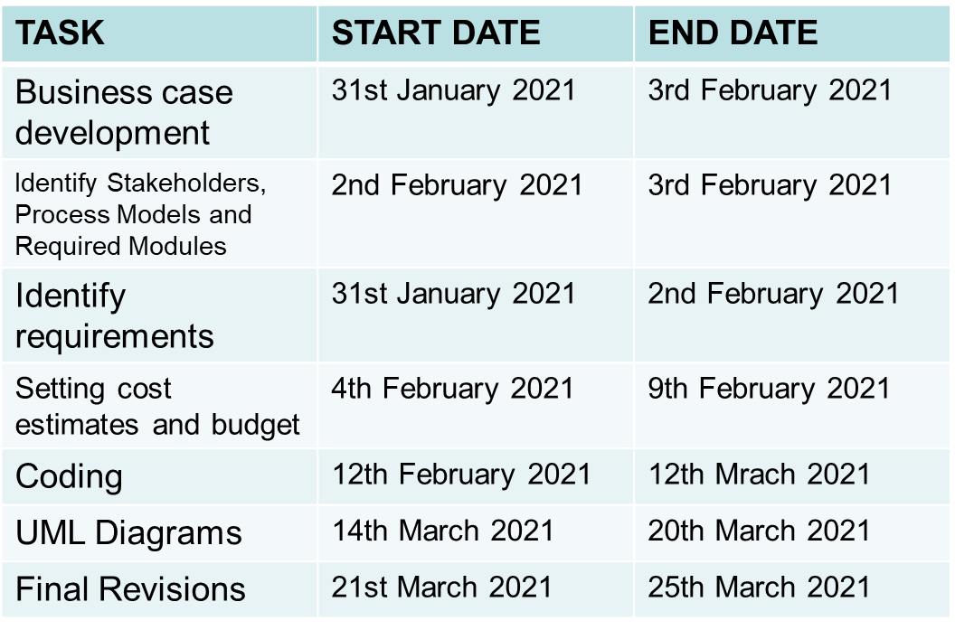

**SOFTWARE AND HARDWARE REQUIREMENTS FOR THE SYSTEM**:

* QR code Scanner.
* Web Application.
* PHP.
* Visual Studio Code
* MySQL Databases.
* JAVASCRIPT, HTML, Graphics Supported Browser.
* System must be connected to the Server.
* At least 1GB RAM is required.

**4.1.2 IDENTIFY JOB ROLES AND RESPONSIBILITIES**:

|  |  |
| --- | --- |
| **Members** | **Roles and Responsibilities** |
| VIGNESH P | Team Leader  -Technical Lead  -Web Developer |
| NIKITH S | Team Member  -Web Developer |
| ROHITH S | Team Member  -Tester |

**JOB ROLES AND RESPONSIBILITIES**

**PROJECT SPONSOR:**

Project sponsor is the one who provides the financial support for the whole project development and execution. They also monitor the process and clarify scope questions. They also provide expert judgement and dictate milestones, key events, or the project end date.

SPONSOR: BHANU PRAKASH (STUDENT)

**SUBJECT MATTER EXPERTS (SME):**

SME is a person who has a special skill or knowledge on a particular job or topic. They have a deep understanding of a particular process, function or machine and hence they help to solve the technical challenges faced by the project.

SME: ROHITH S (TEAM MEMBER)

**PROJECT MANAGER (PM):**

A project manager is a professional in the field of project management. Project managers have the responsibility of the planning, procurement and execution of a project, in any undertaking that has a defined scope.

PM: VIGNESH P (TEAM LEADER)

**TECHNICAL LEAD:**

This person is responsible for overall planning, execution and success of overall complex software solutions to meet customer’s needs. They have to implement best practice and coding standards to the project.

TECHNICAL LEAD: NIKITH S (TEAM MEMBER)

**SOFTWARE DEVELOPERS:**

Individual who builds and creates an application is called software developers. They write, debug and then execute the source code of the software application.

DEVELOPER: VIGNESH P (TEAM LEADER)

NIKITH S (TEAM MEMBER)

**SOFTWARE TESTERS:**

Their main role is to check if the actual result matches the expected result and to ensure the software system is defect free.

TESTER: ROHITH S (TEAM MEMBER)

**WEB DEVELOPER:**

A web developer is a programmer who specializes in, or is specifically engaged in, the development of World Wide Web applications using a client–server model.

WEB DEVELOPER: VIGNESH P (TEAM LEADER)

NIKITH S (TEAM MEMBER)

**CHAPTER - 5:**

**PROJECT EFFORT BASED ON RESOURCE**

**5.1.1 WORK BREAKDOWN STRUCTURE:**

The work breakdown structure of the project is given below:

Implementation

Feasibility

Physical system design

Update system

Users

Maintenance

Online Registration of Bus Pass

Analysis

Requirement

System Design

Development

Testing

Designable

Functional

Non Functional

System Requirements

Cost

Materials

Hire programmer

Hire database engineer

Hire network engineer

Train maintenance

Programming

QA testing

Acceptance Testing

Online

Database

Network

Website

Database

**5.1.2 RISK ANALYSIS**

**PASSENGER PRIVACY AND DATA:**

* Passenger details should provide information about the traveler. We do not sell or share any personally identifiable information volunteered on the bus pass website to any third party (public/private). Any information provided to this portal will be protected from loss, misuse, unauthorized access or disclosure, alteration, or destruction.

**BUS PASS ELIGIBLE CRITERIA:**

* In pursuance of the policy of the Central Government, Corporation has implemented the facility of issuing free bus passes to all the Students below 14 years of age, to travel free from the residence to school.
* In order to carry their school ID card and Xerox copy of an Aadhar card.
* Issuing bus passes to the physically challenged, mentally retarded, blind, deaf & dumb, dwarf persons and etc., and above 60 aged travelers, to travel free by the buses operating in cities / towns. In case of services operating in rural areas, these physically challenged persons are allowed 40%-50 % concession in normal fares.

**CRIME:**

* If your Pass has been stolen, report it to the Police and they will give you a Crime Reference Number. There will be no charge if you order a replacement Bus Pass when you provide you’re Crime Reference Number. Please be aware you will need to submit a Crime Reference Number during the application

**CHAPTER - 6:**

**ESTIMATION OF PROJECT MATRICES**

**6.1.1 FUNCTION POINT ANALYSIS:**

**Objectives of FPA:**

The basic and primary purpose of the functional point analysis is to measure and provide the software application functional size to the client, customer, and the stakeholder on their request. Further, it is used to measure the software project development along with its maintenance, consistently throughout the project irrespective of the tools and the technologies.

**Types of FP Attributes**

Measurements Parameters Examples

1. Number of External Inputs (EI) - Input screen and tables
2. Number of External Output (EO) - Output screens and reports
3. Number of external inquiries (EQ) - Prompts and interrupts.
4. Number of internal files (ILF) - Databases and directories
5. Number of external interfaces (EIF) - Shared databases and shared

**6.1.2 COCOMO MODEL:**

* 1. E = ab(KLOC)^bb
  2. D = cb(E)^b
  3. P = E / D

Where E refers to the effort, D refers to the deployment time, P refers to the productivity and ab, bb, cb, and db are called as coefficients.

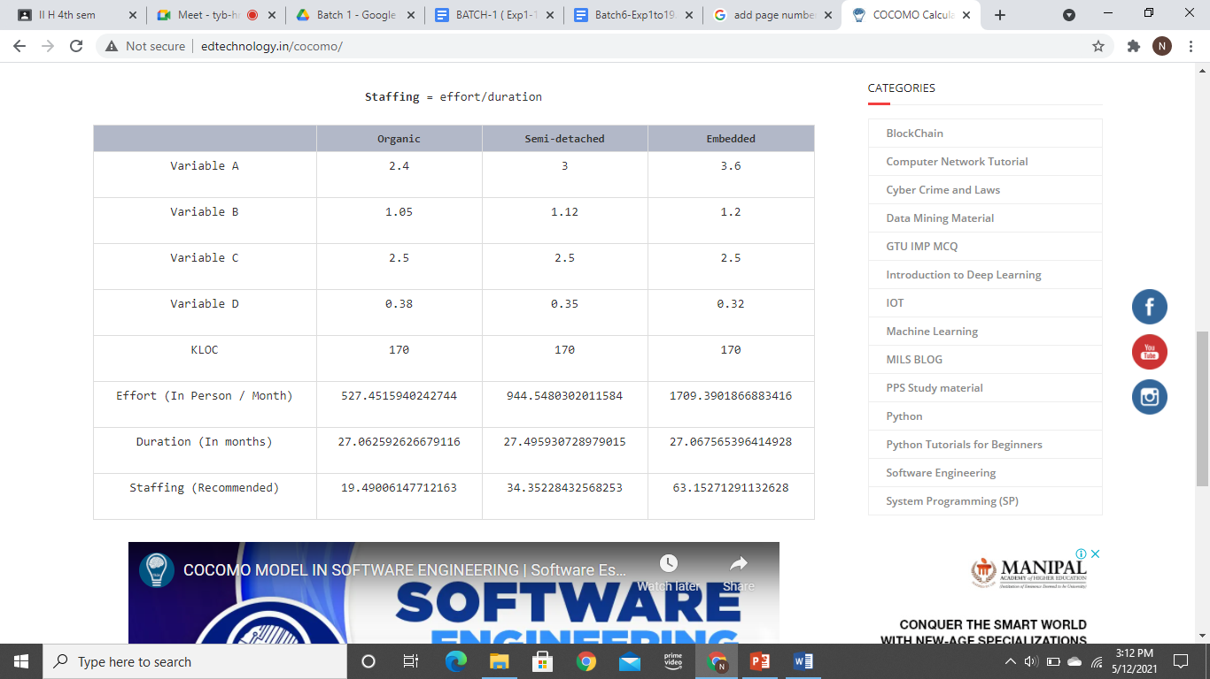

**Table-6.1-Cocomo model**

**CHAPTER - 7**

**DESIGN**

**7.1.1 SYSTEM DESIGN:**

Here we have used the basic software front end design model in order to represent the system architecture of our software model.

LOGIN

BUS PASS   
GENERATED

PAYMENT

VERIFICATION

LOGOUT

REGISTER/

RENEWAL PROCESS

* The above is a simple form of system design diagram which uses front end design.
* This shows a loop of functions that need to be executed when this project is implemented. This is a chain of operations through which this project is implemented.

**CHAPTER - 8:**

**MODELING USE CASE DIAGRAM AND SCENARIOS**

**8.1.1 USE CASE DIAGRAM DESCRIPTION:**

Here there are three actors

* User
* Admin
* TTE

**With QR Code:**

1. The registration use case has the relation with both user and admin.
2. The ID Proof use case has the relation with the User having to submit the ID Proof to admin for verification.
3. Users have to pay the amount for the pass.
4. After payment, User will collect/generate the ticket from the admin.
5. QR Code use case is related to User, TTE and the admin.

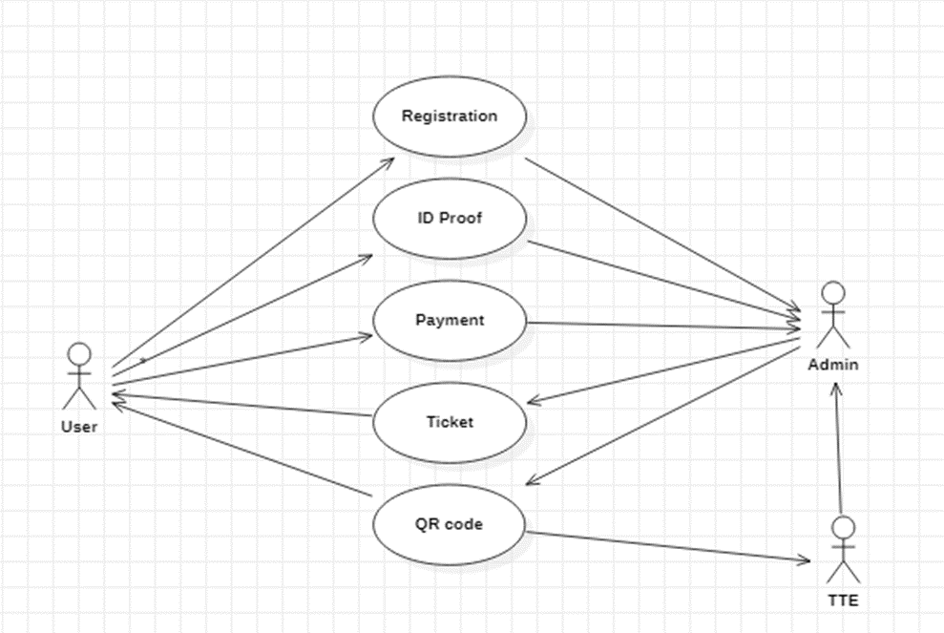

**Without QR Code:**

1. If a user has lost the QR code pass. User has to buy the ticket or pay the penalty.
2. In the TTE use case, TTE has submit the records of the travelers to the Admin

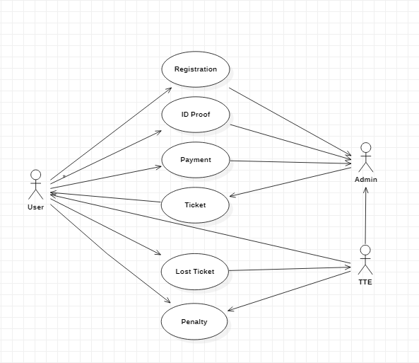

**CHAPTER - 9:**

**ER MODELING FROM THE PROBLEM STATEMENT**

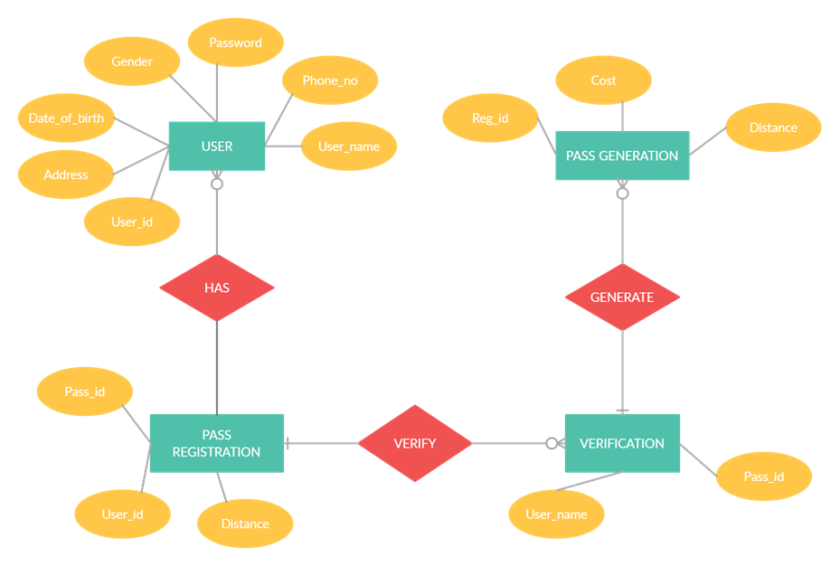**9.1.1 ER DIAGRAM:**

**9.1.2 ER DIAGRAM DESCRIPTION:**

* An Entity-Relationship Model describes interrelated things of interest in a specified domain of knowledge. A basic ER Model is composed of Entity types and specifies relationships that can exist between entities.
* The Details of the product are stored in the product tables
* Each entity has a primary key and unique keys
* The Entities set presented here are

User, Pass registration, Verification and Pass generation.

* All the entities like user, type of registration, reduce duplicates pass.
* There is one to one relationship between travelers and the TTE.
* The issue is raised when someone misuse the pass/ Stolen by someone.
* Another Issues will arise when the user pass has the date of expiration.
* Then the request will be sent to the user for renewal of the pass

**CHAPTER - 10:**

**IDENTIFYING DOMAIN CLASSES FROM THE PROBLEM**

**10.1.1 DOMAIN CLASS:**

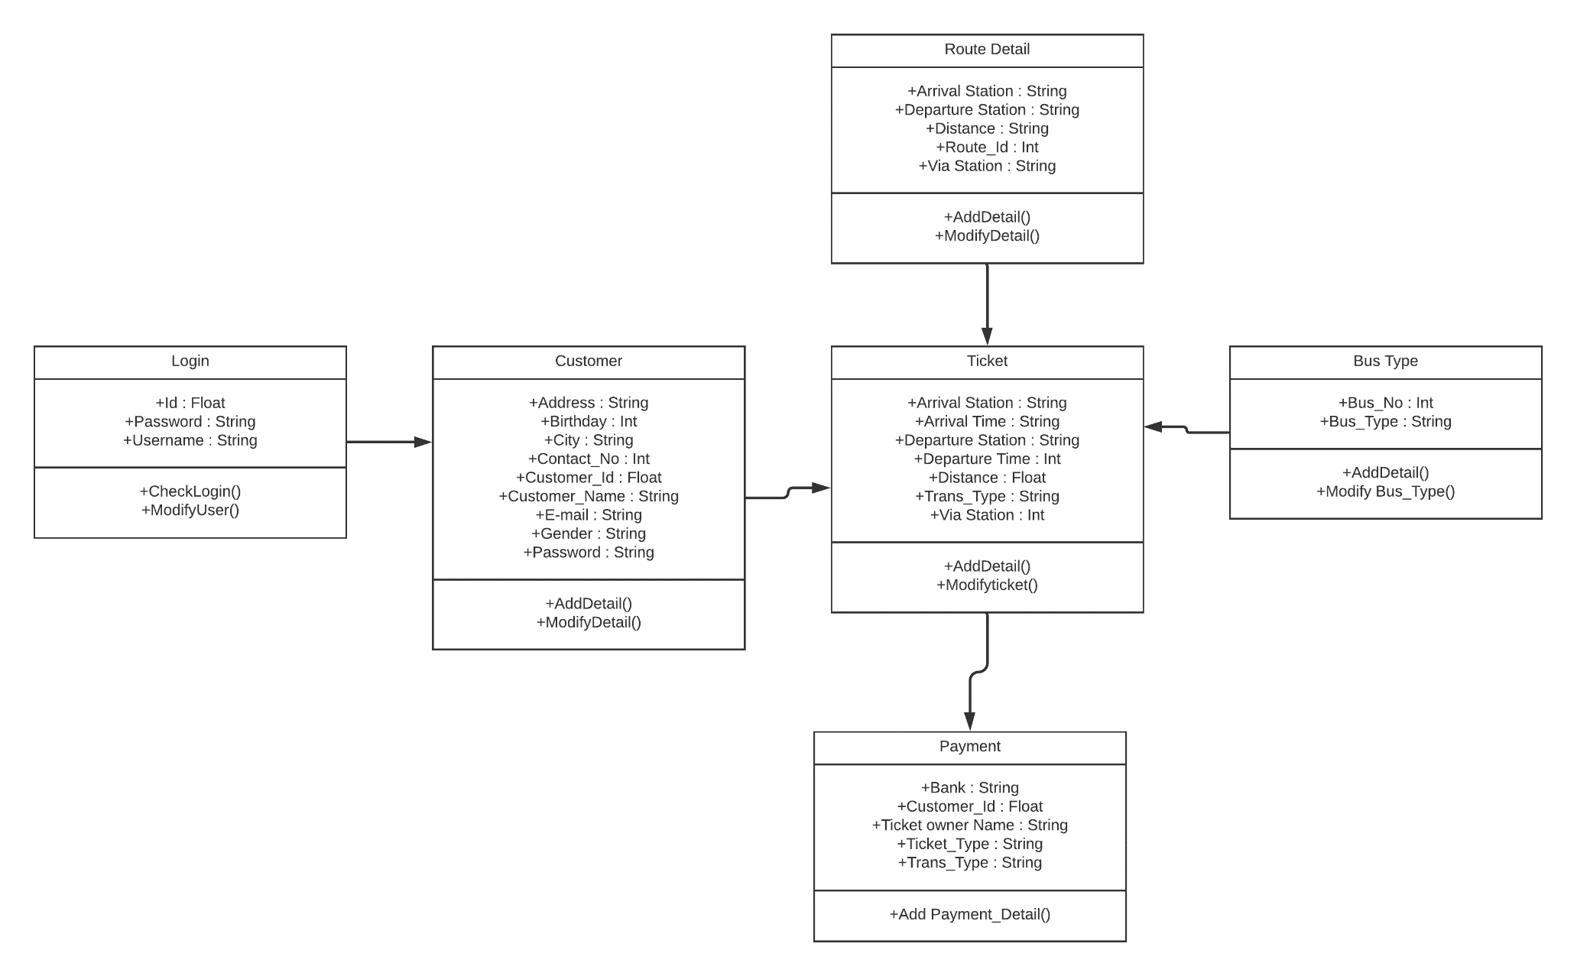

**10.1.2 DOMAIN CLASS DESCRIPTION:**

**General description:** A domain class is a class from the Domain Model that Martin Fowler describes as follow in Patterns of Enterprise Application Architecture: An object model of the domain that incorporates both behavior and data. It is based on attributes and stereotypes, etc.

**Identifying Stereotypes**

Typical domain class stereotypes include:

<<Thing>> = an entity that has mass and volume

<<Event>> = an entity that has a start time and duration

<<Role>> = an entity that executes tasks. For example: plumber, clerk, nurse

<<Type>> = an entity that describes other entities

**Identifying Attributes**

A class contains definitions of all of the attributes its instances will contain. An attribute has four attributes:

Name

Type

Visibility (+ | ~ | # | -)

Initial value (optional)

The type of an attribute usually is not a domain class. These kinds of properties will be represented by associations.

Attribute types include:

Primitive types: Int, double, Boolean

Foundation classes: String, Money, Date

External/imported classes (i.e., classes from external domains)

**CHAPTER - 11:**

**STATECHART AND ACTIVITY MODELING**

**11.1.1 STATECHART DIAGRAM:**

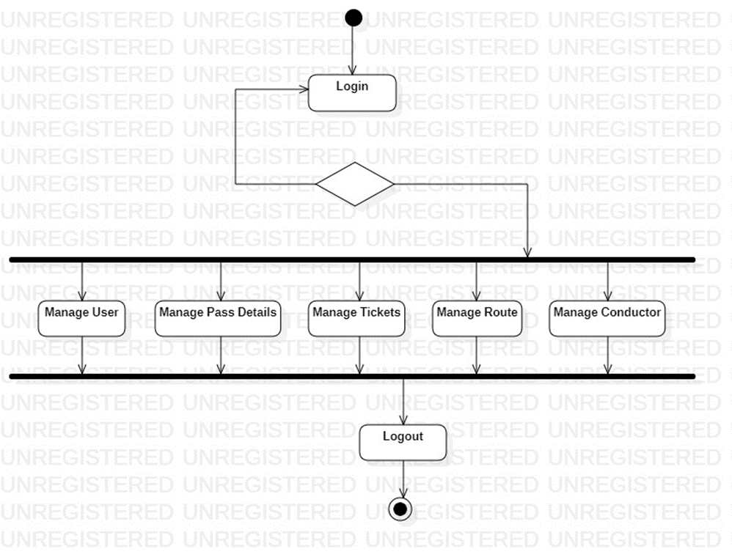FOR ADMIN:

FOR USER: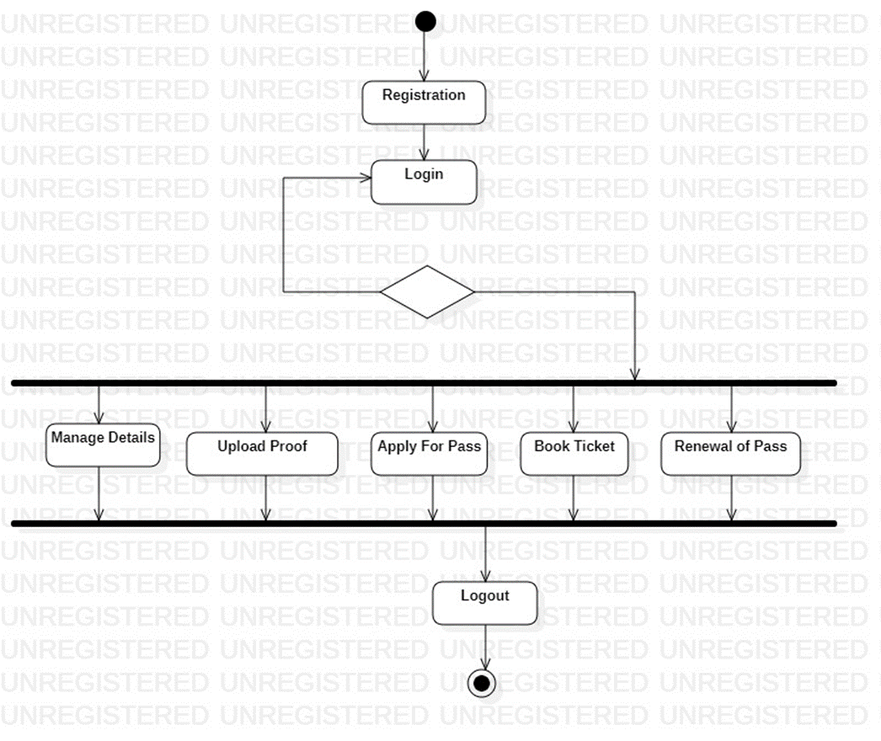

**11.1.2 STATECHART DIAGRAM DESCRIPTION:**

States chart diagram describes the behavior of a single object in response to a series of events in a system.

In this diagrams the states and their descriptions are as follows:

* **States:** State diagram shows the behavior of classes in response to external stimuli.

**FOR ADMIN:**

* **Login:** This state helps the admin to login to the registration system.
* **Verify the Validity**: The Admin will verify the customer’s pass validity.
* **Manage User:** This state helps to create the new users without any rate of limit and also update the user properties and their passwords
* **Manage Pass Details:** This System helps the admin to verify the pass details are valid or not and also the expiration of the customer pass.
* **Manage Tickets:** This system helps the user to check if the pass are available or not.
* Manage Route: This state manages the area of the district.
* **Manage Conductor:** This system states that the store details the conductor and also manages the trip the buses are travelling per day.

**FOR USER:**

* **Registration:** This state helps to register for the new customer.
* **Login:** This state helps the customer to login into bus pass registration.
* **Validation:** This state helps the student valid to bus pass or not.
* **Manage Details:** This state helps the service to find the full details of the customer.
* **Upload Proof:** This state helps the customer to show any proof like an Aadhar card.
* **Apply for Pass:** This state helps the user to apply for Pass.
* **Book Ticket:** This system helps the customer check the ticket and makes sure he/she wants to buy the ticket.
* **Renewal of Pass:** This state helps the passenger to verify the expiry date is end or not whether it ends him/her renewal of the pass.

**11.1.3 COMMUNICATION DIAGRAM:**

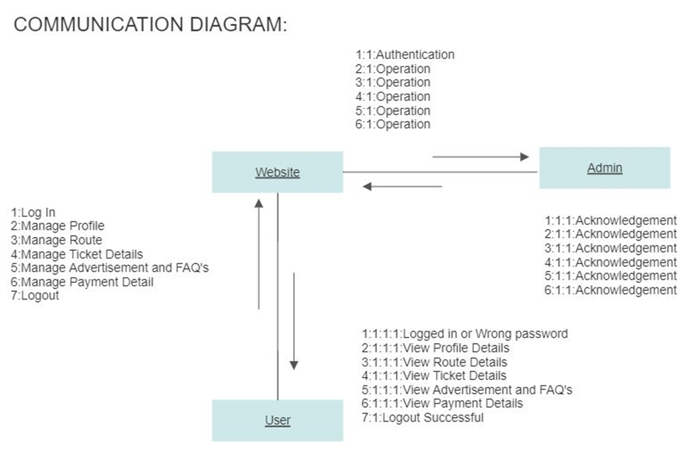

**11.1.4 COMMUNICATION DIAGRAM DESCRIPTION:**

1. Customer logs into the website.
2. Customer registers his personal details into the website.
3. Admin receives notification from the website and he will verify customer details.
4. Customers have to select the area where he/ she want to travel from source to destination.
5. Admin will send the payment response after applying for a pass.
6. Customers will receive pass I.D, QR Code from the website.
7. Finally, Customer will logout successfully.

**CHAPTER - 12:**

**MODELING UML CLASS DIAGRAM AND SEQUENCE DIAGRAM**

**12.1.1 CLASS DIAGRAM:**

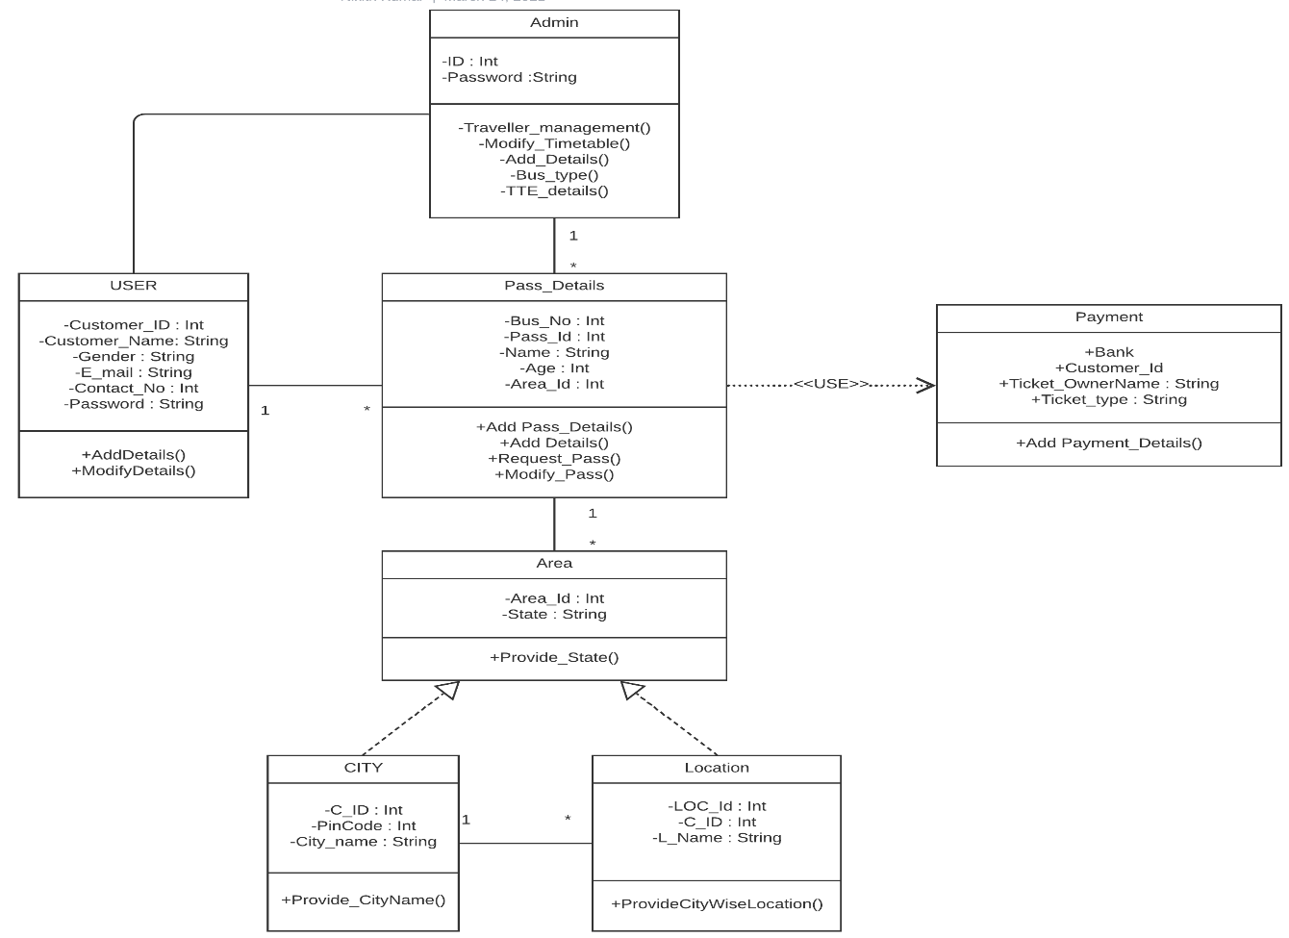

**12.1.2 CLASS DIAGRAM DESCRIPTION:**

* A UML Class diagram is a type of static structure diagram that is used for both general conceptual modelling of the systematics of the application and for detailed modelling translating the model into programming code.
* User Registration: This Class is used for the registration of the user.
* Pass Details: This class contains all the details like Bus Number, Pass Id, Name, Age, Area of the customer have to mention his/her details.
* Payment Method: This Option allows online payment options like UPI, Credit/Debit transactions.
* Area in the class diagram is to provide the details of the location in registration of the pass.
* The most important relationship in the class diagram is the relationship between the user class and pass details class because it has multiplicity relationship.

**12.1.3 SEQUENCE DIAGRAM:**

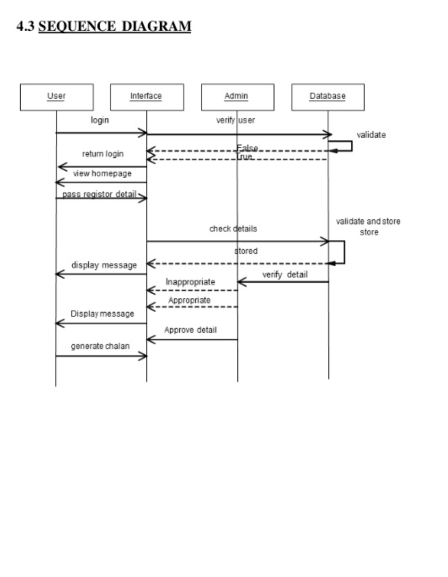

**12.1.4 SEQUENCE DIAGRAM DESCRIPTION:**

There are four objects in this diagram:

1. User

2. Interface

3. Database

4. Admin

* Customer sends a login request to the database, if user checks the login information whether the user given the information is correct or incorrect.
* Interface acts as communication for the user to database and admin.
* User selects the pass register details to book the bus pass ticket. Database will checks the details of the user whether they valid or not for the generation of the bus pass.
* If given details are valid then database gives the appropriate message to Admin.
* Admin will send the approve details of the user to book the bus pass.
* User have to pay the money for the bus pass and generates the QR code.

**CHAPTER - 13:**

**MODELLING DATAFLOW DIAGRAM**

**13.1.1 DATAFLOW DIAGRAM:**

DATABASE

BUS PASS APPLICATION

LOGIN

FORGOT PASSWORD

REGISTRATION

CHANGE PASSWORD

ISSUEING

BUS PASS

ONLINE BUS PASS SYSTEM

PAYMENT

**13.1.2 DATAFLOW DIAGRAM DESCRIPTION:**

* A dataflow diagram is a view of how data is processed in a system in terms of input and output.
* The flow of the data in which the applying for bus pass and bus pass generated which is done through the database engine is shown in the diagram.
* It contains all the user flow entities as pass, registration, application details, generate bus pass.
* It begins with the login system in which the dataflow is between the user database and other registration modules like application details, registration modules like application details, registration details, and payment.
* As it begins with the login system by the user, it generate the details of the bus pass which is stored in the database and then the user have to fill corresponding details with the registration, after the completion the payment the bus pass will be delivered to the customer.
* The flow of the entities is shown in the above diagram.

**CHAPTER – 14:**

**IMPLEMENTATION**

**14.1.1 DESIGNER VIEW:**

 This views displays a pictorial representation of customer or the organization needs. Each button in the above diagram redirects to the links of respective domains and site. This is enabled through HTML and CSS in Microsoft Expression web, a simple software or application to create our own websites.

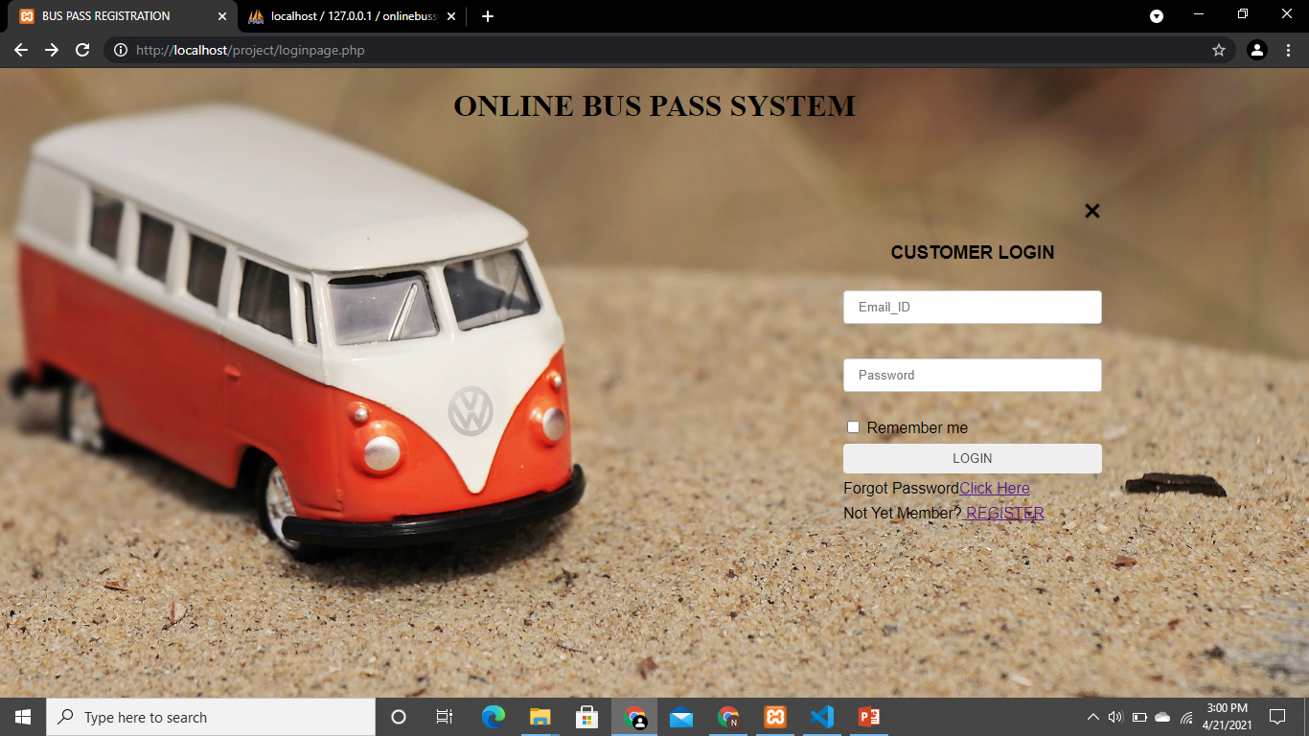

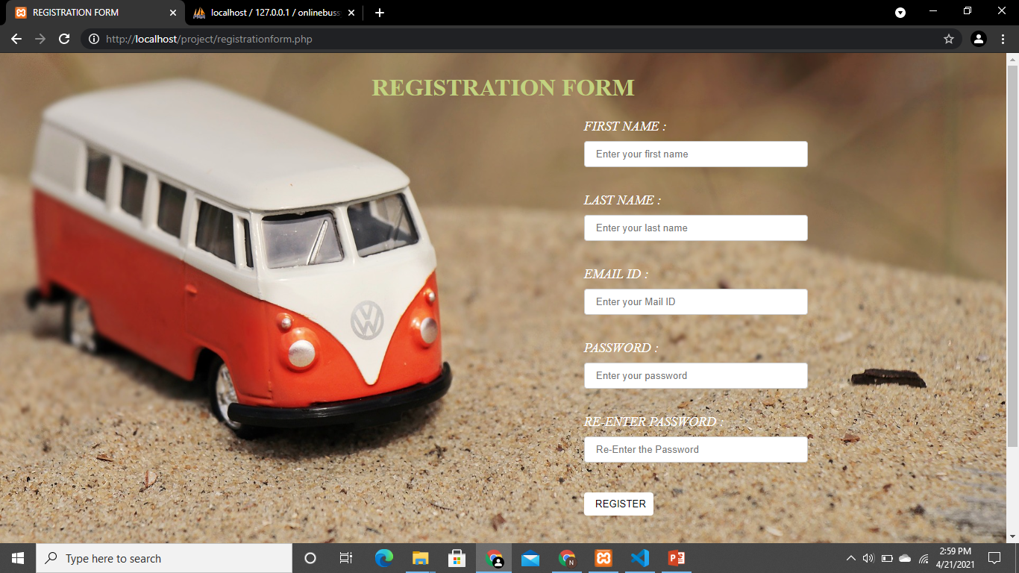

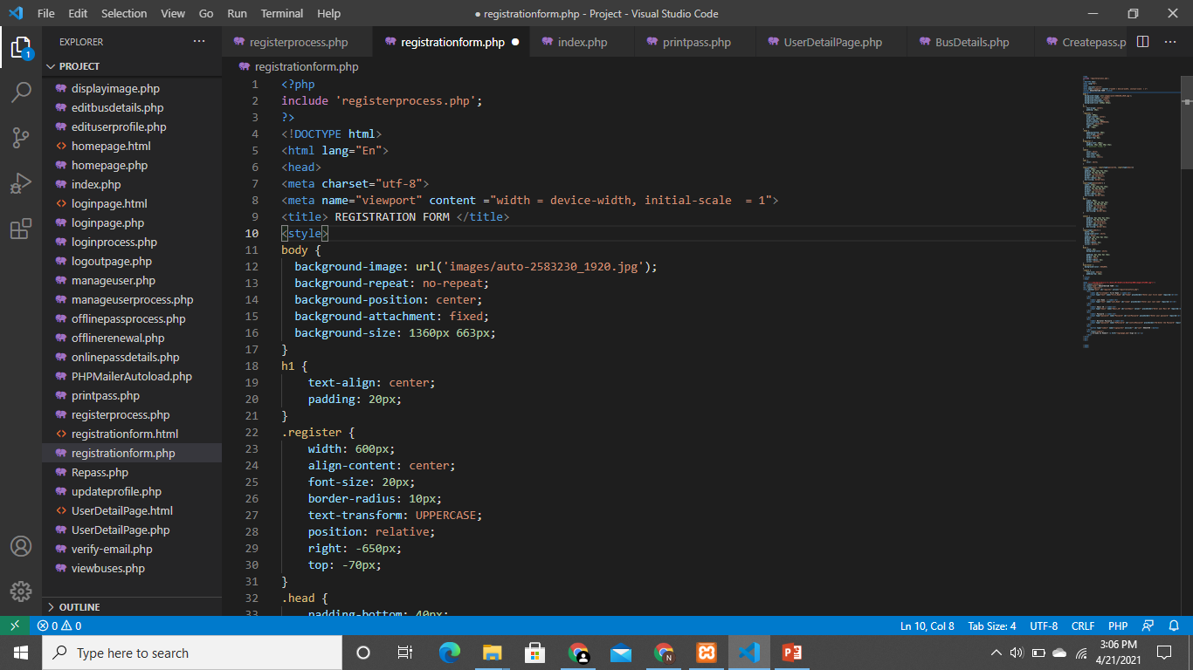

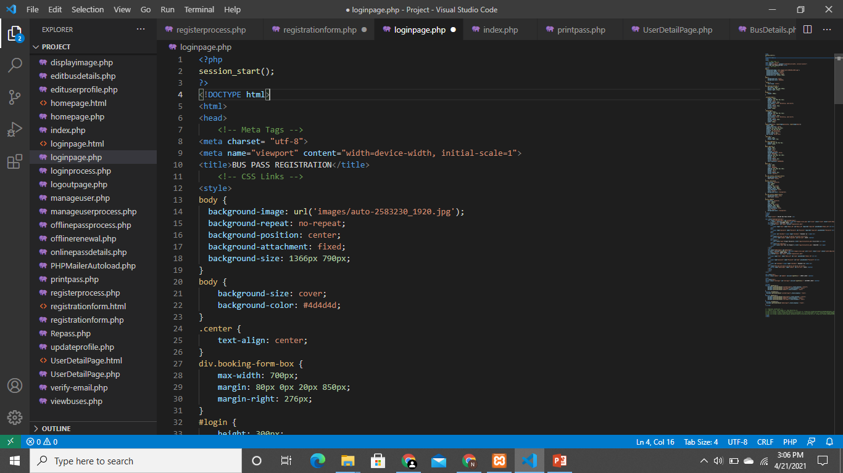

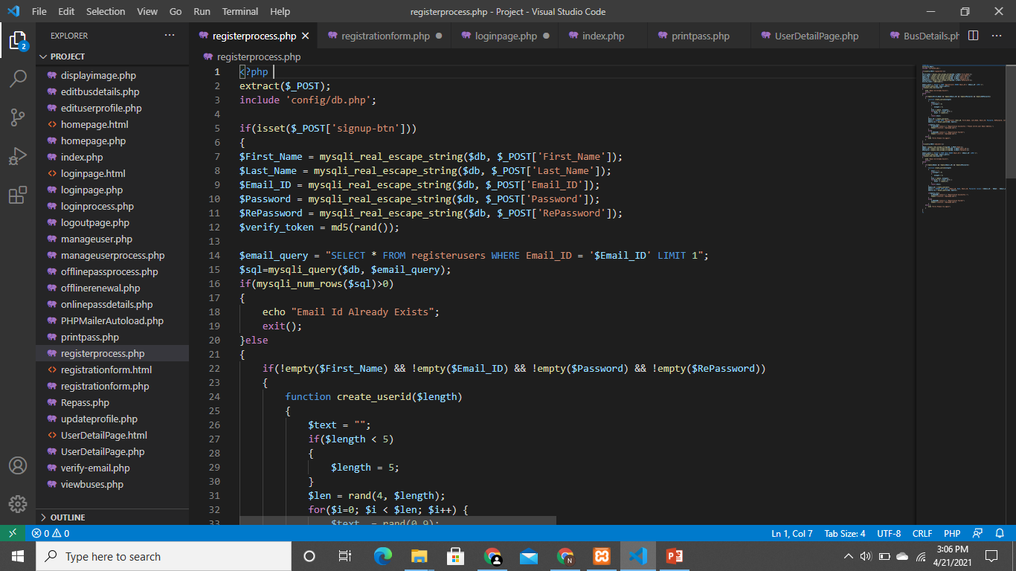

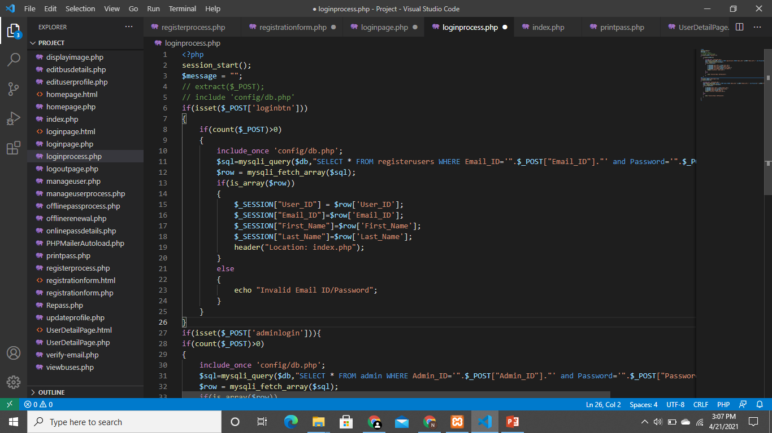

**CHAPTER - 15:**

**ESTIMATION OF TEST COVERAGE METRICS & STRUCTURAL CYCLOMATIC COMPLEXITY**

**15.1.1 CONTROL FLOW GRAPH**

LOGIN

USER

ADMIN

HOME PAGE

REGISTER PAGE

MANAGE USER DETAILS

MANAGE USER DETAILS

MANAGE PASS DETAILS

PAYMENT

MANAGE BUS DETAILS

MANAGE PASS DETAILS

LOGOUT

HOME PAGE

REGISTER PAGE

TRUE

TRUE

FALSE

FALSE

**15.1.2 McCabe's CYCLOMATIC COMPLEXITY**

Cyclomatic complexity is a software metric used to measure the complexity of a program. It is a quantitative measure of independent paths in the source code of the program. Independent path is defined as a path that has at least one edge which has not been traversed before in any other paths. Cyclomatic complexity can be calculated with respect to functions, modules, methods or classes within a program. This metric was developed by Thomas J. McCabe in 1976 and it is based on a control flow representation of the program. Control flow depicts a program as a graph which consists of Nodes and Edges.

Mathematical representation:

Mathematically, it is a set of independent paths through the graph diagram. The

Code complexity of the program can be defined using the formula –

V(G) = E – N + 2

Where,

* E - Number of edges
* N - Number of Nodes
* V(G) = P + 1 ,
* Where P = Number of predicate nodes (node that contains condition).

**CALCULATION:**

* E - Number of edges=16
* N - Number of Nodes=14
* V(G)=16-14+2=4
* Complexity =4

**15.1.3 OPTIMUM VALUE OF CYCLOMATIC COMPLEXITY**

* Cyclomatic complexity is used to gauge the overall intricacy of an application or specific functionality within it. The software metric quantitatively measures a program's logical strength based on existing decision paths in the source code.
* Complexity (M) = Edges (E) – Nodes (N) + Exit Nodes (P)
* Complexity(M)=16-14+1=3;
* Hence it is a **Simple** Module with **low** risk level.

**CHAPTER - 16:**

**DESIGN TESTING SUITES**

**16.1.1 SOFTWARE TESTING**

Software testing is the process of evaluating a software item to detect differences between given input and expected output. Also to assess the features of a software item. Testing assesses the quality of the product. Software testing is a process that should be done during the development process. In other words software testing is a verification and validation process.

**16.1.2 TESTING FRAMEWORKS**

1. **MODULE BASED TESTING FRAMEWORK:**

In the modular testing framework, testers create test scripts on module wise by breaking down the complete application under test into smaller, independent tests. In simple words, testers divide the application into multiple modules and create test scripts individually. These individual test scripts can be combined to make larger test scripts by using a master script to achieve the required scenarios.

1. **KEYWORD DRIVEN TESTING FRAMEWORK:**

In Keyword-driven testing, we use a table format to define keywords or action words for each function or method that we would execute. It performs automation test scripts based on the keywords specified in the excel sheet. By using this Framework, testers can work with keywords to develop any test automation script, testers with less programming knowledge would also be able to work on the test scripts.

**16.1.3 MASTER TEST PLAN:**

|  |  |
| --- | --- |
| **TESTING OBJECTIVE** | **FOCUSING ON PERFORMNCE ISSUE** |
| Test Items | Register, Login, Email Verification, Pass Validate Notification |
| Features to be Tested | Login verification, Generating Alerts For pass validity |
| Features not to be Tested | MySQL Connectivity |
| Approach | Manual testing |
| Required Hardware/Software | Web Browser, Internet Connectivity. |
| Risks | Alert Management |
| Testers & Schedule | Vignesh P, April 1st 2021 |
| Estimate | - |

**16.1.4 MANUAL TESTING**

|  |  |  |  |
| --- | --- | --- | --- |
| **TEST AREA** | **INPUT** | **TEST**  **DESCRIPTION** | **RESULT** |
| Login Module | Login username  and password | Permits the user  To enter into the  Website. | Tested |
| Registration  Module | User details(Name, Phone  Number, Email ID, etc...) | Saves the  Registered user  Details to MySQL Database | Tested |
| Pass  Generation | Admin generates the  Bus pass to customer | Sends the message to  Customer | Tested |

**CHAPTER - 17:**

**DEPLOYMENT REPORT**

**USER:**

* Customer logs into the website using email.
* He/she fills their personal details.
* Customer selects the area and choose the bus number from the bus details page.
* He/she creates the pass details from website.

**ADMIN:**

* Admin login into online bus pass system.
* The admin will manages the user’s information and creates/renews the user's passes.
* Checks the area
* Alert message will send to the customer if the details is correct.
* Admin will add the bus details and modify the bus details to the database.

**PASS GENERATION:**

* Required details of the customer will be submitted to admin.
* Admin approves the user as the trusted one then the bus pass will be generated and send to the student’s mail.

**RENEWAL PASS:**

* Customer can login to his account for the renewal of bus pass.
* Required details entered by the customer.
* Then payment process will carried out.
* Then the process is completed the user bus pass will be renewed automatically and send to user's mail.

By using this website, each week has shown the report of different users. It is useful for the commuter who are facing problems with current manual work of bus system. It makes passenger easy to travel. Website shows maximum accuracy result and is efficient. Therefore, the valuable time of the customer is saved.

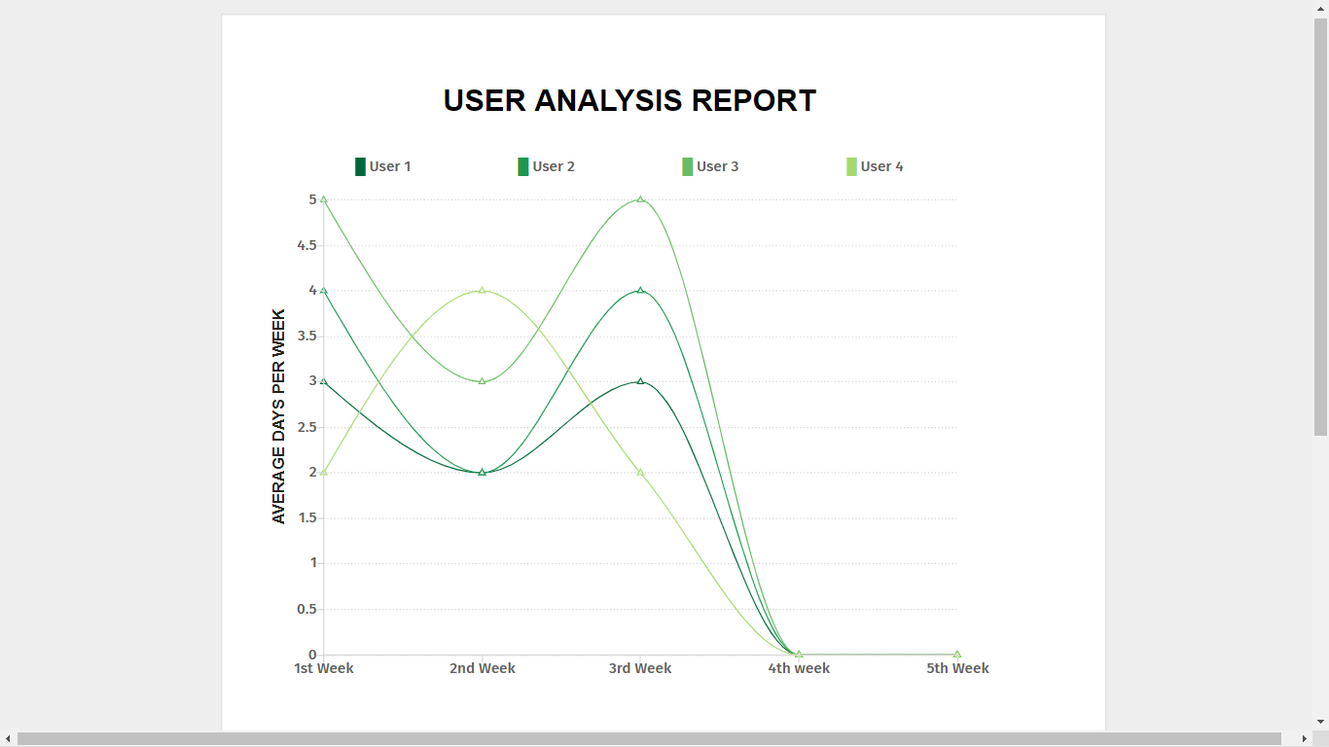

**CHAPTER – 18:**

**CONCLUSION**

At the Completion of this project we come to know that this system is useful for students and passengers who want to generate the pass from online. But there is a one bug about to paying fees online because generally the village students and passengers do not have online banking facility so this problem is occurs for state bus pass. But this is useful for city bus pass systems and metro train pass systems for big cities.

**CHAPTER – 19:**

**REFERENCES**

https://www.google.com

https://www.w3schools.com/php/default.asp

https://stackoverflow.com

http://www.hyderabadbusroutes.in/show-buses/all

SQL server tool kit